**Name:** ____________________________________ **Due** **Date:** ­­­­­­­­­­­­­­­­­­­­­­­­­_________________



CURRENT EVENTS ARE EVENTS AND ISSUES OF INTEREST CURRENTLY FOUND IN THE NEWS.Current events will be categorized into 3 categories- **Local/State** (news in our immediate area) / (news that happens in MI), **National** (news from anywhere else in the U.S.) or **International** (news happening in other parts of the world).

**Directions:** Choose an age-appropriate current event from a newspaper, magazine, or Internet site. The date on the article must be within the last two weeks. Then CLOSE read the article! (Directions and THINKMARKS are on the back of your list of Great Sites for Current Events sheet). Attach the article with **Thinkmarks** to this sheet. (5 points)

Answer the questions/complete the activities below! The world wants to know your thoughts!

**I. The Details** (1 point each)

**1.** Publication/Website Name:  **2.** Publication date/Date of the article:

**3.** Is this a **Local/State**, **National**, or **International** news story? (Circle one)

**4.** What is the headline/title of your article?

**5.** What is the main idea of the article?

**II. Article Summary Paragraph & Reflection/Opinion Paragraph** (7 points each)

**\*\*Please type your summary/reflection for a neater presentation.**

**Summary Paragraph**: In your first sentence, **tell WHO did WHAT, WHERE and WHEN it happened, and WHY and HOW it happened.** This paragraph should contain some of the main points discussed in the article. It should also tell why the subject is Newsworthy/or tell the Purpose of the article. Your summary should ***not*** be a list, and should ***not*** include quotes, opinions or minor details such as lengthy statistics/figures. It should be written in your own words: Please use/edit for proper sentence structure, spelling, grammar, and punctuation. !!!!!We practiced this together!!!!!

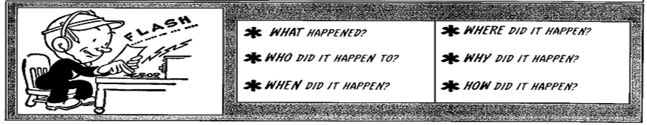

**Reflection/Opinion Paragraph:** It’s time to share your **opinion** on the article! This paragraph should be your **personal response** to what you read. How did it make you feel? What was your reaction to what the writer had to say about the story? Did you like what you read? Did you agree/disagree with the article/author? What do you think should be done? What made you choose this article?

Make possible connections or relate how it affects our community, state, country, or world. Your paragraph should not just be a list of answers to these questions!!!

**Current Events Requirement Checklist**

* My current event is dated within the last 2 weeks and is from a reputable/approved source/website
* My current event is not about a sports competition or entertainment
* I understand my current event

I have completed the:

* **Extra! Extra! Details Questions** on the top of this page **(5 points)**
* **Article Summary Paragraph (7 points)**
* **Reflection/Opinion Paragraph (7 points)**
* **Social Studies Connections Questions** on the back of this page **(10 points)**
* **I have attached a copy of my article with my “Thinkmarks” on it.** **(6 points)**

**Points Possible: 35 Total**

**Your Grade:**