My 7th Grade Memory Book
DUE:___________________
Parent/Guardian Signature______________________

Our final project for 7th grade will be a memory book. You will create a book about the memories you’ve had throughout 7th grade and your life. You will be allowed to choose about half of what is in this book. The other page topics will be given to you or will consist of essays we have written for class.
***This packet will be turned in with your book.do not lose this!!***

A. Mandatory Pages
- Title Page/Cover with your name, title, graphics-clipart or photographs
- A Table of Contents-save for the last page
- Page numbers on every page of your book
- All About Me Page
- Thank You Letter
- Nicey Nice List
- Letter to My Senior Self
+
B. The Final Drafts of:
- I Am Poem
- Favorite Relative Essay
- Thankful Poem
+
C. At least five free choice writing assignments-see below

Family tree-see attached
hobbies
sports
vacations
friends
Favorite Teacher
your house
pets
cars
fashion
Thank You Letter-see attached
favorite things
family members
holidays
music/movies/TV
Other ideas?? See me ☺

Work Days
- We will have work days scheduled where you will be able to work on your memory book in class. You will also be expected to work on this at home.

- Pace yourself... DO NOT wait until the last minute to finish this!

Mandatory Page Requirements
1. All About Me
This page should contain at least three paragraphs, 8-10 sentences each about you and who you are. Use the “10 things you should know about me” journal entry for ideas. You can include normal facts or you can include things that someone may not know about you.

This page needs to include a picture of you – digital, adhered, or scanned in.
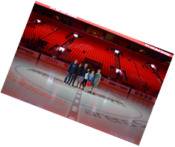
All About Me
My name is Cristina Marie Therriault. I was born in February at Cottage Hospital in Grosse Pointe Farms, Michigan. I was the eighth child born to my parents. I have four older brothers and three older sisters who have cared for and protected me my entire life. I really believe that I have the best mom and dad in the entire universe. They have raised all of us to be kind, loving, considerate, and successful. I lived in the same house, in the same room, for 27 years of my life. I attended Trombly Elementary School, Pierce Middle School, and Grosse Pointe South High School. Growing up I always knew I wanted to be a teacher. I graduated from the University of Michigan-Dearborn in 1997 with a degree in teaching. I earned my master of education degree, with a specialization in Adolescent Development and Education, from the University of Michigan as well. I was lucky enough to get my first teaching job soon after I graduated. I began teaching at Brownell Middle School in September of 1998.

In October of 2002 we had our first power-forward, Dean Therriault. When Dean was about three years old he got the best gift ever: a baby brother!!! Our cute center, Paul Therriault was born on a cold, sunny St. Patrick’s Day in 2006. They are the absolute joy of my life!

I love spending time with my family and friends along with reading, going to the beach, cooking, baking and playing tennis. My favorite thing to do is to watch my boys play hockey and baseball. If I had nine lives to live, I know that I would be a photographer in at least one of those lives. I love the art of photography and I have a portfolio which won several awards in high school. I love to travel and my dream vacation would be to travel to Italy and Bora Bora.

My biggest pet peeve would be mean and hurtful people. I always try to remember to treat others the way I would want to be treated and I believe if more people did this, the world could be even better.

2. Thank you letter
Follow assignment sheet in this packet

- Nicey-Nice List…
We will be completing this as a class.

- Letter to my senior self…
You will be writing a letter to your future self, the person you will be when you are a senior preparing to graduate from high school. See directions.

*******************************************************

Family Tree-optional free choice
- You must include at least three generations; you, your parents, your grandparents.
- You must include first and last names of everyone and birth city.
- Pictures will get you extra ☺

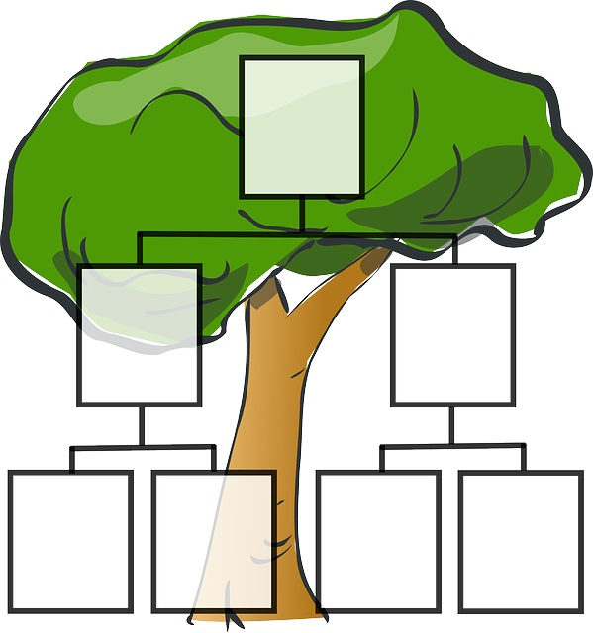

Necessary Requirements
Here are the requirements you must meet to get a “B” for this project.

- YOU MUST FOLLOW ALL DIRECTIONS IN THIS PACKET FOR EACH PIECE YOU INCLUDE IN YOUR BOOK.
- Your book should be bound in a one inch, three ring binder.

INSTRUCTIONS FOR ALL FREE CHOICES
- 5 additional “Free Choice” pages
- Every page should have a title.
- Text at least 2 paragraphs, 8-10 sentences each on each additional page
      - Font size must be 14 or smaller (not including titles). Only readable fonts may be used in the main part of your writing pieces– Old English and other difficult fonts may not be used.
      - Correct spelling, punctuation, and grammar. –This is huge!!
- You can have a full page of pictures. HOWEVER, the following page should have at least 2 paragraphs of writing explaining the full page of pictures. – A page with all pictures does not count as one of your additional pages.
- You may put a border on your pages.

If you want an “A”, you will have to go above and beyond these requirements:

Ways to raise your grade to an “A”
- Include more than 5 free choice pages.
- PICTURES, PICTURES, PICTURES!!!
- Be especially creative on a specific page.
- Wow me with something you think up to show you really went above basic requirements.

Book Plan

Title Page

Table of contents

All About Me Page

Thank You Letter… Page

Letter to My Senior Self

Free Choice Page #1: _______________________________

Free Choice Page #2: _______________________________

Free Choice Page #3: _______________________________

Free Choice Page #4: _______________________________

Free Choice Page #5: _______________________________

Other free choice Pages-please fill in titles
_______________________________

_______________________________

_______________________________

_______________________________
I Am Poem
Thankful Poem
My Favorite Relative Essay
Nicey Nice List

A Letter to My Senior Self
You are to write a letter to your future self, the person you will be when you are a senior preparing to graduate from high school.

Follow the format below:

Dear Twelfth- grade Me (or name),
I am writing this letter in Mrs. Therriault’s 7th grade English class. At the time, I am…(continue by writing about your current physical appearance. Here are some ideas: height, weight, shoe size, style of clothes, hair color and style, special features of your appearance like braces, glasses, or contacts, pierced ears, etc.) Make this paragraph flow so it does not sound like a list.

These are some of my favorite things. (Continue by identifying and describing some of your favorites: books, movies, songs, activities, sports teams, foods, places, websites, apps, colors, etc.) Make this fit who you are. Do not write a list.

There are many important people in my life right now. (Continue by mentioning some people who are very important to you-family, friends, others-providing specifics and showing why or how they are important.)

Many things have happened this school year in our world, in our school, and in my life. (In this paragraph detail some important events that have occurred in each of the three categories above.)

These are my hopes and dreams for the future. (Conclude your letter by telling about your plans and dreams for the future. Ideas-What would you like to accomplish in high school? Academic, personal, athletic, stage, music, and/or club goals? What to you envision for yourself after high school? College? Career? How do you see your adulthood?)

Your old self,
(signature)

Thank You Letters
Memory Book

Please choose one of the following special people who has inspired you to write a Thank You letter to:

- Parents
- Grandparents
- Teacher/Coach
- Aunt, uncle, cousin, etc.

Your job will be to thank your special person for being an important part of your life and for INTANGIBLE things such as: love, support, encouragement, acceptance, strength, courage, good decision making, opportunity, advice, etc.

Your letter will need:
SALUTATION- Dear ___(Their name)____________,

BODY-You need to choose 2 of the most important things you are thankful for and compose one paragraph for each of those specific things.

CLOSING- Love, ____(Your name)____________

Remember:
- Be sincere and creative
- Good luck

“A” Grade Memory Book Grading Rubric-THIS MUST BE TURNED IN WITH YOUR BOOK
Please follow the order of the rubric for your book.

Cover (10)
Name, Date, Hour, photo/graphic _____

Table of contents (10) _____
*Page Numbers
All About Me (15 total) ______
*Title
*3 paragraphs
*Spelling/Punctuation
*Picture of you

Thank You Letter… (15 total) _______
*Title
*Follow Format
*Spelling/Punctuation
Letter to My Senior Self…(15) ______
*Title
*Follow Format
Free Choice – #1(10) REQUIRED _____
*Title _______________________
*2-3 paragraphs
*Spelling/Punctuation

Free Choice – #2 (10) REQUIRED _____
*Title _______________________
*2-3 paragraphs
*Spelling/Punctuation

Free Choice – #3(10) REQUIRED _____
*Title _______________________
*2-3 paragraphs
*Spelling/Punctuation

Free Choice – #4 (10) REQUIRED ______
*Title ________________________
*2-3 paragraphs
*Spelling/Punctuation

Free Choice –#5 (10) REQUIRED _____
*Title ________________________
*2-3 paragraphs
*Spelling/Punctuation

EXTRA Free Choice- #6 (10) _____
*Title ________________________
*2-3 paragraphs
*Spelling/Punctuation

EXTRA Free Choice- #7 (10) _____
*Title ________________________
*2-3 paragraphs
*Spelling/Punctuation

EXTRA Free Choice-#8 (10) _____
*Title ________________________
*2-3 paragraphs
*Spelling/Punctuation

EXTRAS-PLEASE LIST BELOW:

I Am Poem (10) _____
Favorite Relative Essay (10) _____
Nicey Nice List (5) _____
Thankful Poem (5) _____
Book Binding (2) _____
Rubric (3) _____
Work Habits on Work Days (20) _____
TOTAL /200

