**Northeast Region**

**Here you will find all the information relating to the Northeast region of the United States.   
Students will be expected to know the 11 states, points of interest, and capitals of the northeast.**

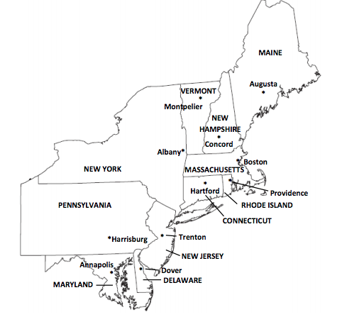  
1. Connecticut - CT - Hartford  
2. Maryland - MD - Annapolis  
3. Maine - ME - Augusta  
4. New York - NY - Albany  
5. Pennsylvania - PA - Harrisburg  
6. Vermont -VT - Montpelier  
7. Delaware - DE - Dover  
8. Massachusetts - MA - Boston  
9. New Jersey -  NJ - Trenton  
10. New Hampshire - NH - Concord  
11. Rhode Island - RI - Providence  
  
**They should also know:**  
- Land and Water of the Northeast Region  
- Climate  
- Products and Natural Resources  
- Landmarks  
- Culture

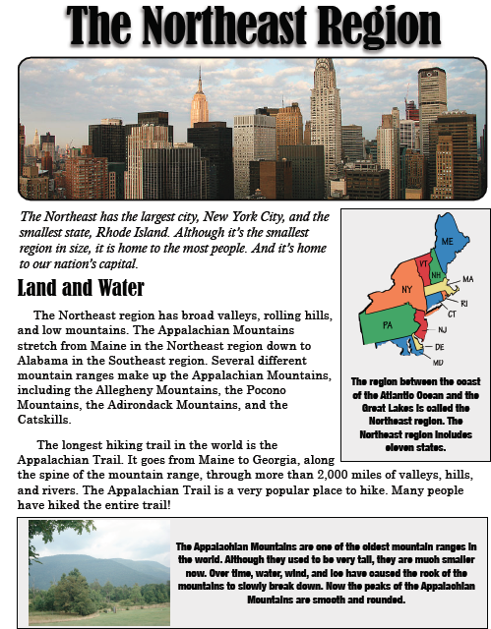

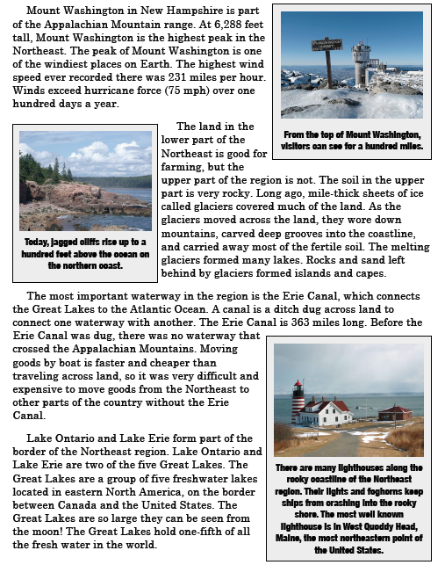

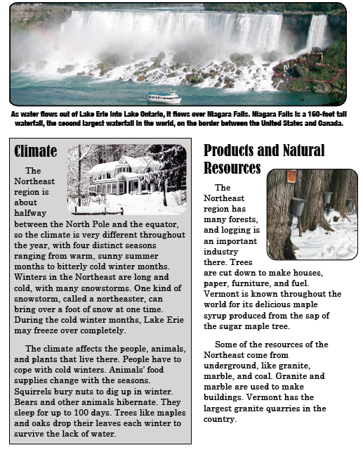

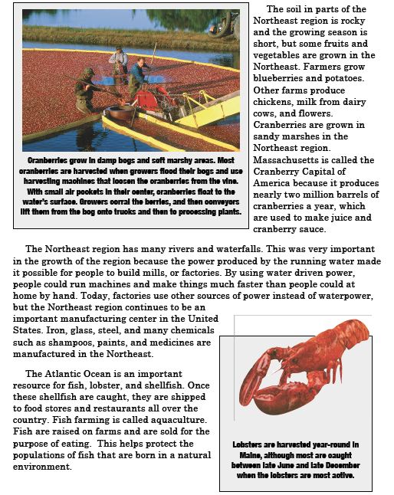

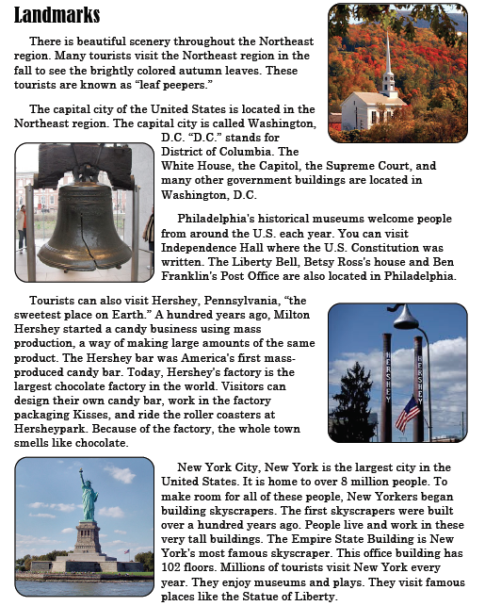

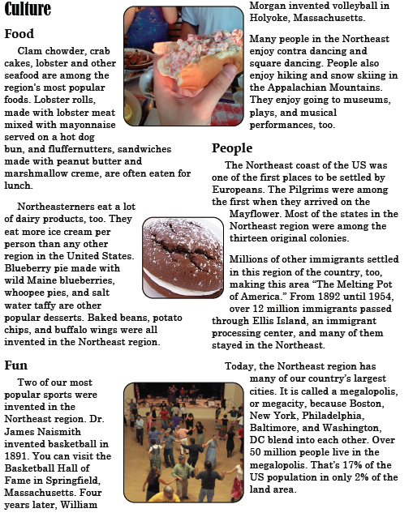

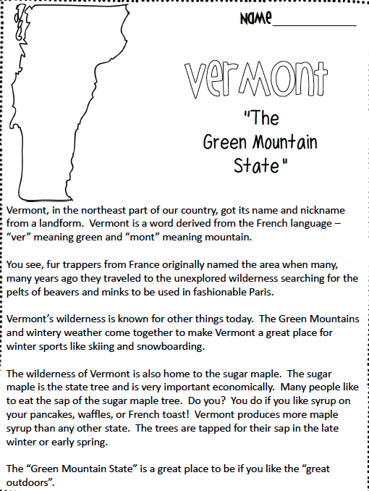

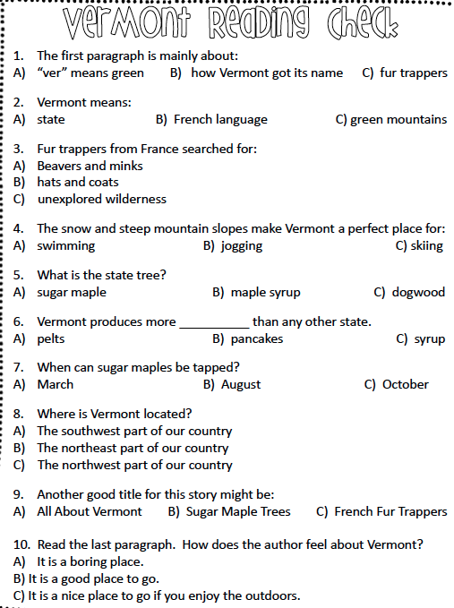

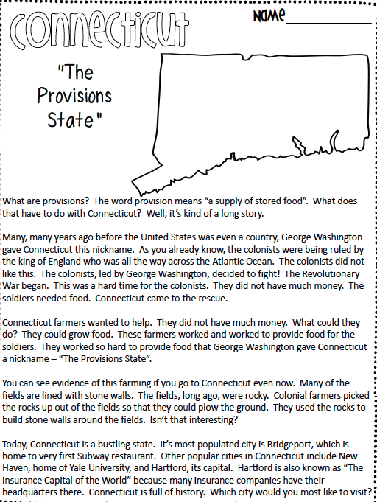

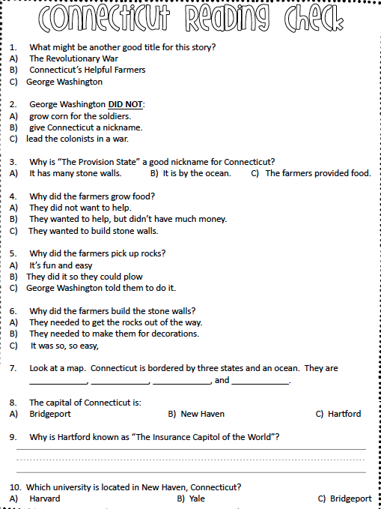

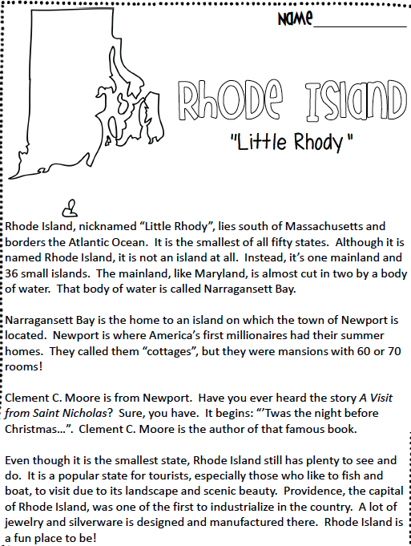

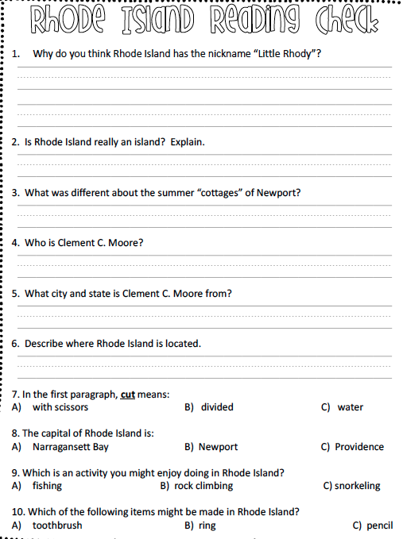

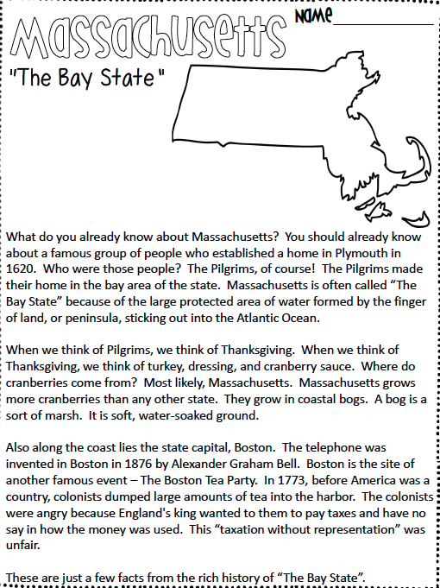

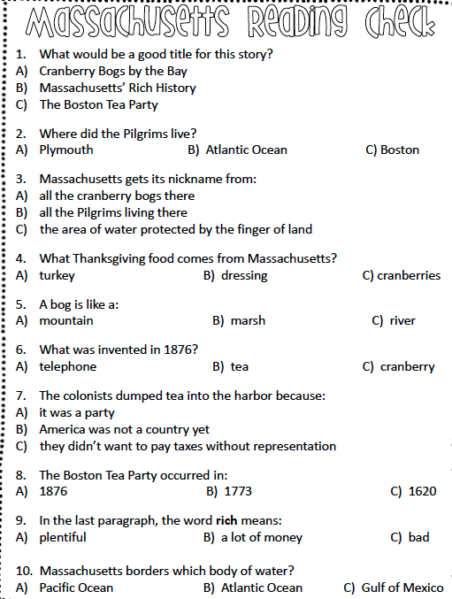

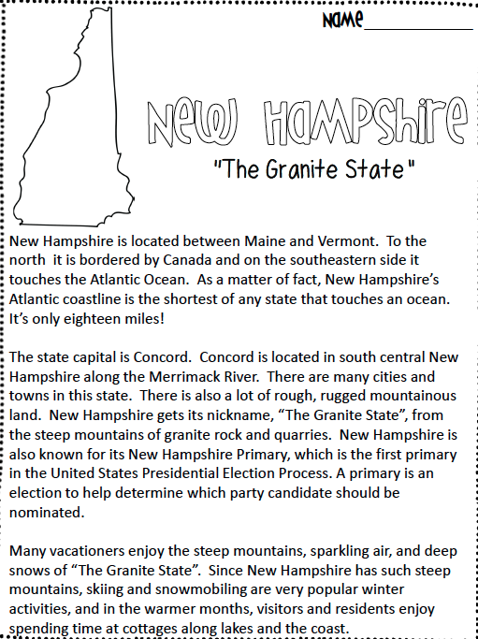

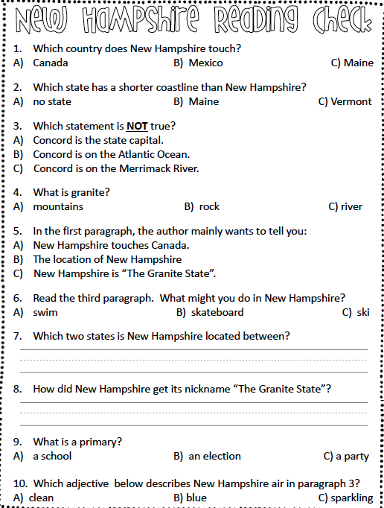

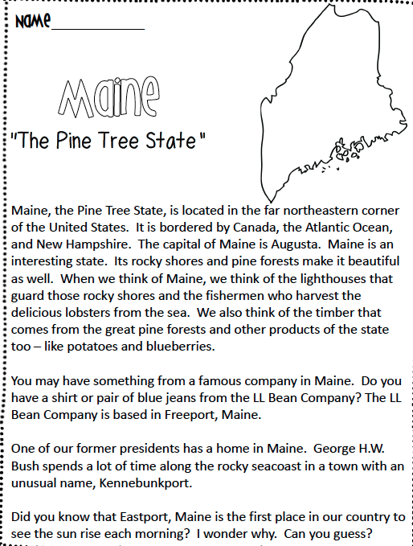

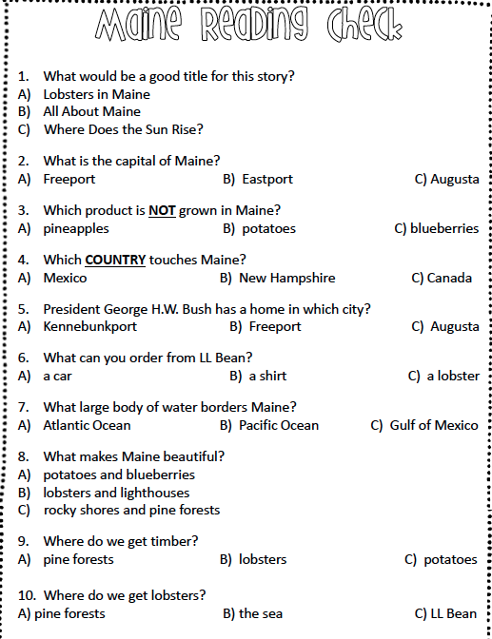

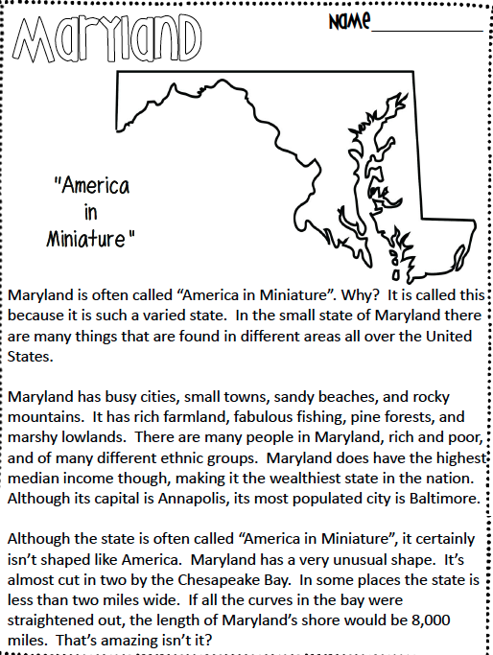

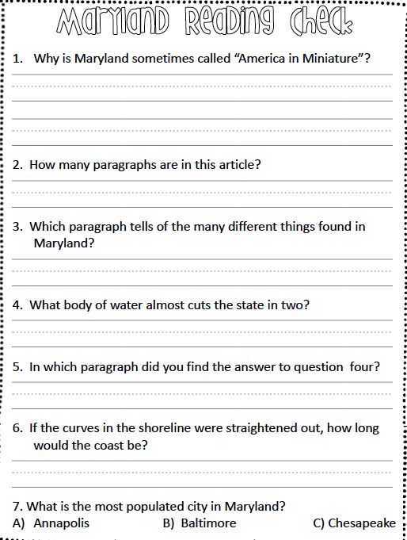

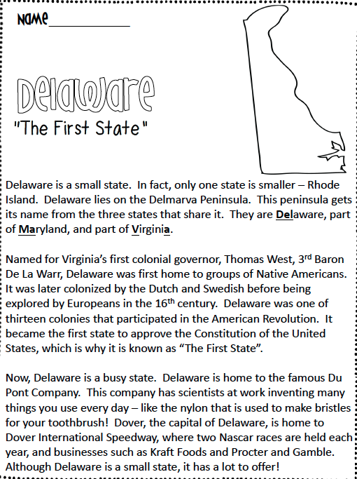

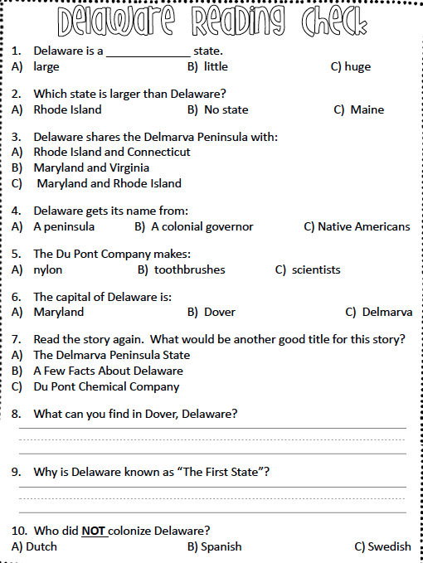

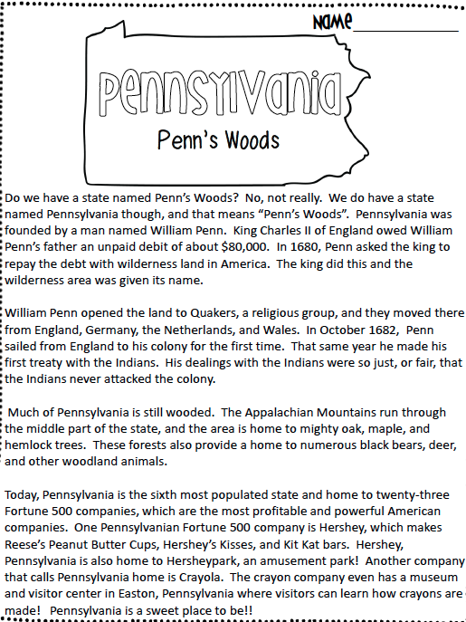

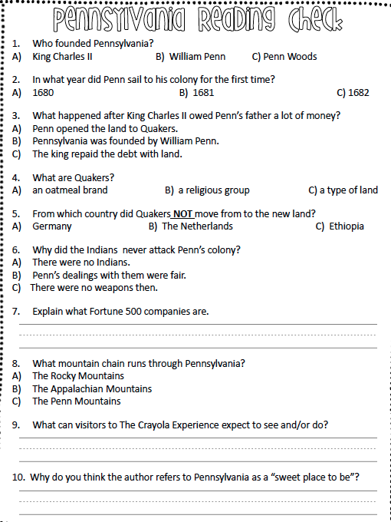

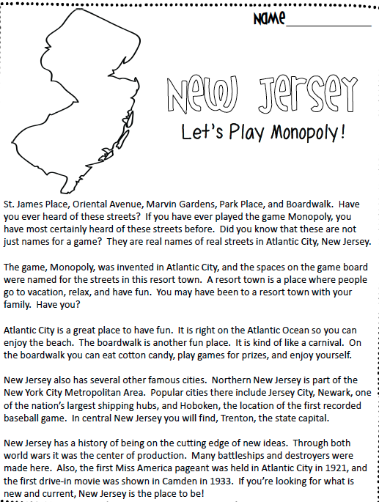

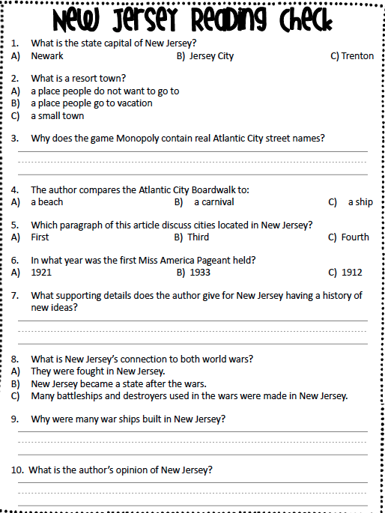

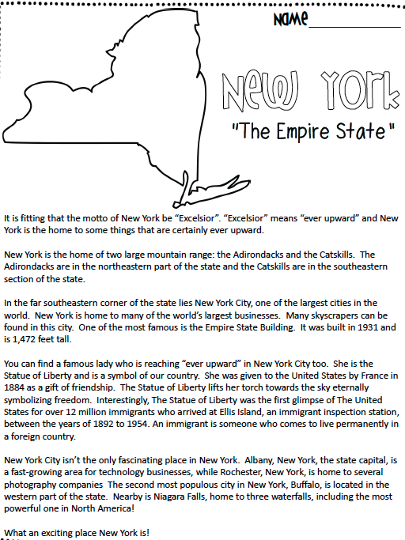

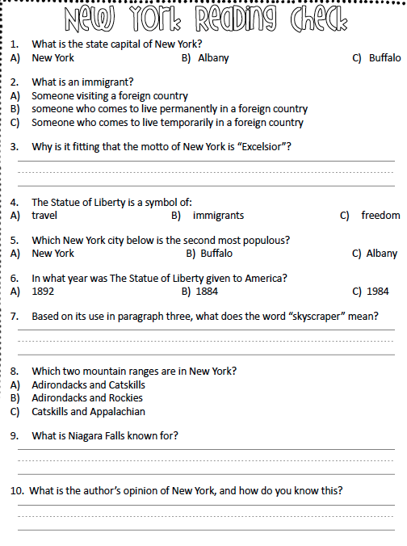

Notes:

­­­­­­­__________________________

__________________________

__________________________

__________________________

__________________________

__________________________

__________________________

__________________________

__________________________